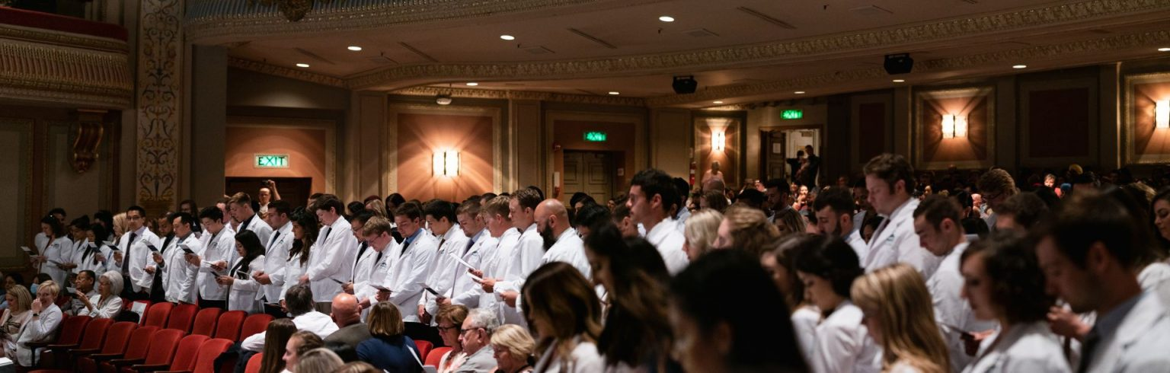
2023 White Coat Ceremony Student Presentation
Friday, June 2, 2023 • 3:00 pm (Doors open at 2:30 pm for family & friends)
The Capitol Theatre • 19 S. Third Street
Vicky Koch (pronounced Cook) – Cell 425-269-4293
Arrive: 2:00 PM
- YOUR WHITE COAT will be at the Capitol Theatre for you to pick up - Cleaned and pressed.
- Enter the building from the 4th Street entrance in the back, stage door, proceed to the loading dock
- Keep your personal belongings to a minimum; do not carry items with you, leave them with your family. Or there will be bins to leave items with the Capitol Theatre security in the back. If you use the bins you will need to return through the back door to retrieve them after the ceremony. All remaining items will be returned to the school on Monday to the security office.
- You will receive your Arnold P. Gold Foundation lapel pin; put it on your left lapel.
- We have limited time so please be on time

Line Up: 2:45 pm
- Line up for the processional. There will be someone to help you.
- You will proceed out the door and down the alleyway.
- You will be directed to the audience seats, about 34 per row. Fill the rows completely.
- Remain standing until entire class, faculty and administration (platform party) arrives
- There will be a program on your seat to follow along.

Ceremony Begins: 3:00 pm
- LeAnn Hunter will open the ceremony.
- Note: The Ceremony will be live streamed and recorded link on the PNWU Webpage
- Dr. Scandalis’ Welcome Message, Dr. Lawler, Mr. Vornbrock
- Student Speakers (2)
- Keynote Speaker: Dr. Marie Cadwell Meyer, PNWU Inaugural Class of 2012
- After Dr. Cadwell Meyer concludes her speech the coating will begin.
- You will be directed to stand ONE ROW AT A TIME and move to the stage.
- Coating will begin at the front row.
- Note: You will not return to the same seat.
- Have your white coat neatly folder over your left arm – unbuttoned

Coating:
- One at a time, proceed to the podium and announce: YOUR NAME, YOUR HOMETOWN, and YOUR UNDERGRADUATE SCHOOL. No extraneous comments, please be professional! Speak directly into the microphone. But do not touch it.
- Proceed to the center of the stage to be coated, keep your arms back and low by your bum.
  - Hint: left arm in coat; right arm in coat; right shoulder back to turn; then shake coaters hand
Left – Right – Turn to Shake Coater’s Hand
- Try not to turn around and look at your sleeves.
- Feel free to straighten your hair and coat as you proceed to be congratulated by Dr. Scandalis.
- Shake hands with Drs., Scandalis, Lawler and Mr. Vornbrock

Exiting the Stage:
- After you shake the administration hands, exit the stage down the stairs
- Return to your original row and any available seat. Important, do not bring personal belongings to leave at your seat – you will not be returning to your original seat.

Ceremonial Oath:
- When all students have been coated Dr. Scandalis will ask you to stand and lead you in the oath.
- THE OATH IS LOCATED ON THE BACK OF YOUR PROGRAM
- Read with conviction!
- Dr. Scandalis will conclude the ceremony.

Recessional:
- Dr. Scandalis will lead the platform party off the stage. The seated Faculty will follow Dr. Scandalis.
- Students will follow row by row, front to back, after the platform party passes.

TIPS:
- SILENCE YOUR CELL PHONE
- Please refer to the website for proper attire suggestions. Ladies: short dresses can be a problem when
you lift your arms to fix your hair on stage…the audience is lower than you are!
- Keep your personal belongings to a minimum; do not carry items with you, leave them with your family.
- Eat something for lunch and drink plenty of water.
- Wear shoes that you can easily navigate stairs in.
- Enjoy the moment, this is a great achievement!
- CONGRATULATIONS AND GOOD LUCK ON ROTATIONS!

